**Lab 5**

**Case conversation**

**Program #1**

**P#1: To convert the small letter into capital.**

.model small

.stack 100h

.data

str1 db 'Enter lower case letter: - $'

str2 db 0dh,0ah,'Upper case: - $'

.code

start:

;initialie data segment

Mov ax,@data

Mov ds,ax

;display string

mov ah,09

lea dx,str1

int 21h

;input character

mov ah, 01h

int 21h

;lower to upper case conversion

sub al,20h

mov bl,al

;display string

mov ah,09

lea dx,str2

int 21h

;display character

;display string

mov ah,02

mov dl,bl

int 21h

mov ah,4ch

int 21h

end start

**Program #2**

**P#1 EQU**

.model small

.stack 100h

.data

p equ 41h

.code

start:

mov ax,@data

mov ds,ax

mov ah,02

mov dl,p

int 21h

mov ah,4ch

int 21h

end start

**P#2 EQU**

.model small

.stack 100h

.data

Msg1 equ 'type your name$'

Msg db msg1

p equ 41h

.code

start:

mov ax,@data

mov ds,ax

Mov ah,09

lea dx, msg

int 21h

mov ah,02

mov dl ,p

int 21h

mov ah,4ch

int 21h

end start

**P#3: Use EQU in program for new line.**

.model small

.stack 100h

.data

line equ 0AH

carriage equ 0DH

.code

start:

mov ah,02

mov dl, 'a'

int 21h

mov ah, 02

mov dl,line

int 21h

mov ah, 02

mov dl,carriage

int 21h

mov ah,02

mov dl, 'b'

int 21h

mov ah,4ch

int 21h

end start

**Task**

1. **Create a program which convert capital to small.**

**Source Code:**

.model small

.stack 100h

.data

.code

start:

mov ah,01

int 21h

add al,20h

mov ah ,02

mov dl,al

int 21h

mov ah,4ch

int 21h

end start

**Output:**

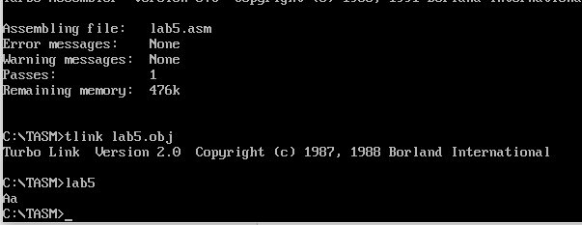

1. **Create a program which print! on 1, @ on 2, # on 3 and so on up to 9.**

**Source code:**

.model small

.stack 100h

.data

SOH equ 21h

STX equ 40h

ETX equ 23h

EOT equ 25h

ENQ equ 2Ah

ACK equ 7Eh

BEL equ 5Ch

BS equ 5Dh

TAB equ 7Dh

.code

start:

mov ax,@data

mov ds,ax

mov ah ,02

mov dl,SOH

int 21h

mov ah,02

mov dl,0ah

int 21h

mov ah,02

mov dl,0dh

int 21h

mov ah ,02

mov dl,STX

int 21h

mov ah,02

mov dl,0ah

int 21h

mov ah,02

mov dl,0dh

int 21h

mov ah ,02

mov dl,ETX

int 21h

mov ah,02

mov dl,0ah

int 21h

mov ah,02

mov dl,0dh

int 21h

mov ah ,02

mov dl,EOT

int 21h

mov ah,02

mov dl,0ah

int 21h

mov ah,02

mov dl,0dh

int 21h

mov ah ,02

mov dl,ENQ

int 21h

mov ah,02

mov dl,0ah

int 21h

mov ah,02

mov dl,0dh

int 21h

mov ah ,02

mov dl,ACK

int 21h

mov ah,02

mov dl,0ah

int 21h

mov ah,02

mov dl,0dh

int 21h

mov ah ,02

mov dl,BEL

int 21h

mov ah,02

mov dl,0ah

int 21h

mov ah,02

mov dl,0dh

int 21h

mov ah ,02

mov dl,BS

int 21h

mov ah,02

mov dl,0ah

int 21h

mov ah,02

mov dl,0dh

int 21h

mov ah ,02

mov dl,TAB

int 21h

mov ah,4ch

int 21h

end start

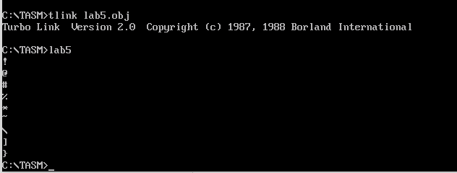**Output:**

**Create a program using EQU**

**Source Code:**

.model small

.stack 100h

.data

A equ 61h

.code

start:

mov ax,@data

mov ds,ax

mov ah ,02

mov dl,A

int 21h

mov ah,4ch

int 21h

end start

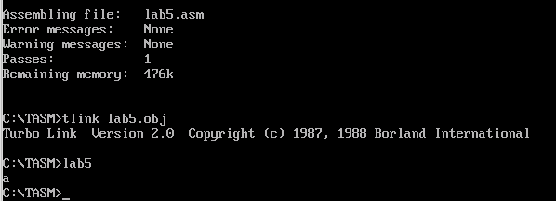**Output:**